| Berkley: | EVAN SPOTTE-SMITH | electrolyte degradation and solid electrolyte interphase (SEI) formation in metal-ion batteries

| Cambridge: | May Ching LAI | Electron Microscopy of energy materials

# Research Proposal: Characterizing Energy Materials and Understanding Electrolyte Degradation in Metal-ion Batteries

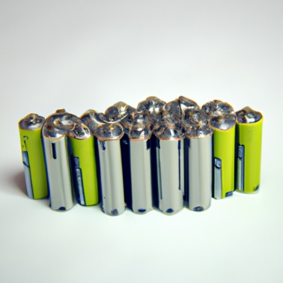

## Abstract:

This research proposal aims to combine the expertise of two students, May Ching Lai and Evan Spotte-Smith, to advance the understanding of energy materials and electrolyte degradation in metal-ion batteries. May Ching Lai focuses on utilizing electron microscopy techniques, such as focused ion beam-scanning electron microscopy (FIB-SEM) and transmission electron microscopy (TEM), to investigate the properties of Li(Ni0.8Mn0.1Co0.1)O2 cathode materials. On the other hand, Evan Spotte-Smith employs computer simulations, including density functional theory and chemical reaction networks, to predict electrolyte degradation mechanisms and develop design rules for novel electrolytes. By combining these approaches, this research proposal aims to contribute to the development of high-performance and long-lasting energy storage systems.

## Introduction:

The demand for high-capacity, long cycle-life, and safe energy storage systems has driven the rapid advancement of cathode materials for lithium-ion batteries. Li(Ni0.8Mn0.1Co0.1)O2 is a promising cathode material, but its structural deterioration and limited long-term cycle stability present significant challenges. Understanding the properties of this material at the nanoscale is essential for enhancing electrode stability and performance, particularly for applications in electric vehicles. Additionally, electrolyte degradation in metal-ion batteries is a major contributor to capacity fade and the formation of passivating solid electrolyte interphase (SEI) layers. Developing methods to control electrolyte reactivity is crucial for the creation of reliable and long-lasting batteries. Therefore, this research proposal aims to combine electron microscopy techniques and computer simulations to gain insights into energy materials and electrolyte degradation.

## Methods:

May Ching Lai will synthesize battery cells and electrochemically cycle them in collaboration with others. They will utilize focused ion beam-scanning electron microscopy (FIB-SEM) to prepare thin lamellae for transmission electron microscopy (TEM) studies. FIB-SEM tomography will be conducted to create 3-dimensional models using Dragonfly software. TEM techniques, such as energy dispersive X-ray and electron energy loss spectroscopy analysis, will evaluate the distribution of transition metals. Diffraction patterns and high-resolution TEM will provide information on crystal structure, strain, and cracking. The data acquired from TEM will be analyzed using Hyperspy, a Python library for multidimensional data analysis.

Evan Spotte-Smith will employ computer simulations to predict electrolyte decomposition mechanisms. They will combine density functional theory, statistical mechanics, and chemical reaction networks to understand electrolyte degradation and solid electrolyte interphase (SEI) formation in metal-ion batteries. By utilizing atomistic insights, they will identify design rules to aid in the development of novel electrolytes and battery charging protocols.

## Expected Results:

The combination of May Ching Lai's electron microscopy techniques and Evan Spotte-Smith's computer simulations is expected to provide valuable insights into energy materials and electrolyte degradation in metal-ion batteries. May Ching Lai's research will contribute to the understanding of Li(Ni0.8Mn0.1Co0.1)O2 cathode materials' properties at the nanoscale, including mechanical integrity issues and their impact on long-term cycle stability. Evan Spotte-Smith's simulations will offer predictions of electrolyte decomposition mechanisms and help establish design rules for novel electrolytes that can mitigate capacity fade and enhance the performance of metal-ion batteries.

## Sustainable Impact:

The findings of this research proposal will support the development of high-performance and long-lasting energy storage systems, addressing the growing demand for reliable and safe batteries in various applications, especially in the transportation sector. By advancing the understanding of energy materials and electrolyte degradation mechanisms, this research proposal contributes towards the goal of replacing internal combustion engines with electric vehicles, thereby reducing greenhouse gas emissions and promoting sustainability.

## Conclusion:

The combination of electron microscopy techniques and computer simulations in this research proposal offers a comprehensive approach to characterizing energy materials and understanding electrolyte degradation in metal-ion batteries. The insights gained from this study will have a substantial impact on the development of high-performance and sustainable energy storage systems. By improving the understanding of cathode materials and electrolyte reactivity, this research has the potential to contribute significantly to the advancement of electric vehicles and the transition to a clean energy future.